2024 Membership Form | 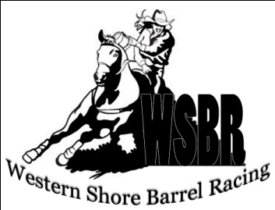

Name: _______________________________________________________________________________
Phone #: _________________________________________
Email (this will be the email prize money will be sent to- can put more than 1 email):
__________________________________________________________________________________________________________________________________________________________________________
Address: ________________________________________________ Postal Code: __________________
Horse(s) & Back Number(s):______________________________________________________________
MUST be a current WSBRC Member (subject to approval by the board) to participate in WSBRC events

Please check of the membership type that applies to you:

___ Youth ($10) ___ Adult ($15) ___ Family ($25)

Please List any additional Family members. Also include their horse and back # if possible:

- ______________________________________________________________________________

- ______________________________________________________________________________

- ______________________________________________________________________________

- ______________________________________________________________________________

- ______________________________________________________________________________

Please send completed forms and payment (E-transfers accepted) to:
WSBRCpayments@gmail.com
(902)746-4662
1620 Chebogue Rd, Kellys Cove, NS, B5A 5G3

